20.40: (a) The temperature at point c is 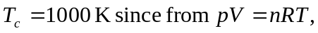 the maximum temperature occurs when the pressure and volume are both maximum. So

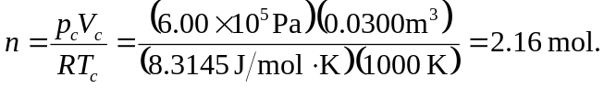
(b) Heat enters the gas along paths ab and bc, so the heat input per cycle is 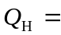
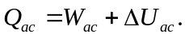 Path ab has constant volume and path bc has constant pressure, so

For an ideal gas, so
Then

(c) Heat is removed from the gas along paths cd and da, so the waste heat per cycle is 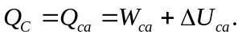 Path cd has constant volume and path da has constant pressure, so

From (b),

(d) The work is the area enclosed by the rectangular path abcd,

(e)

